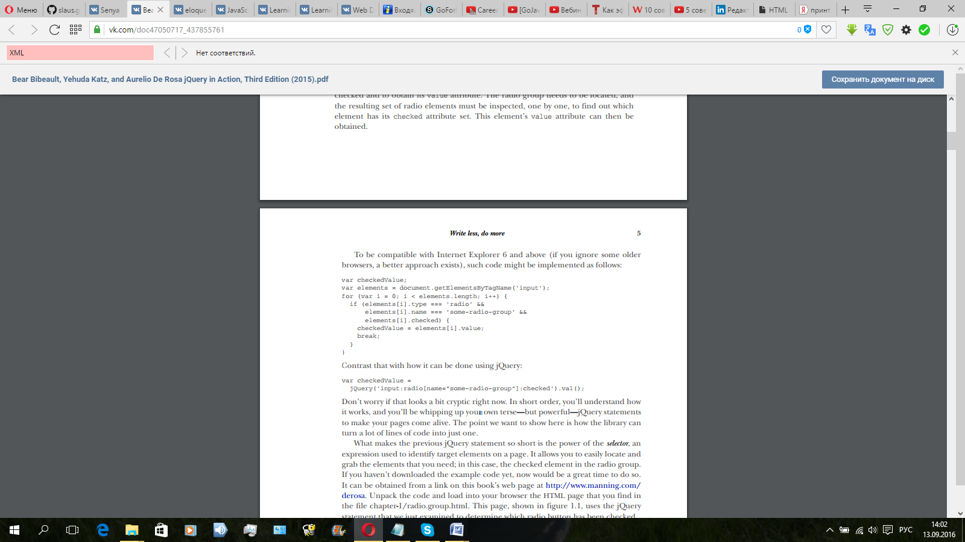

Contrast that with how it can be done using jQuery: var checkedValue = jQuery('input:radio[name="some-radio-group"]:checked').val();

Нажатие на кнопку